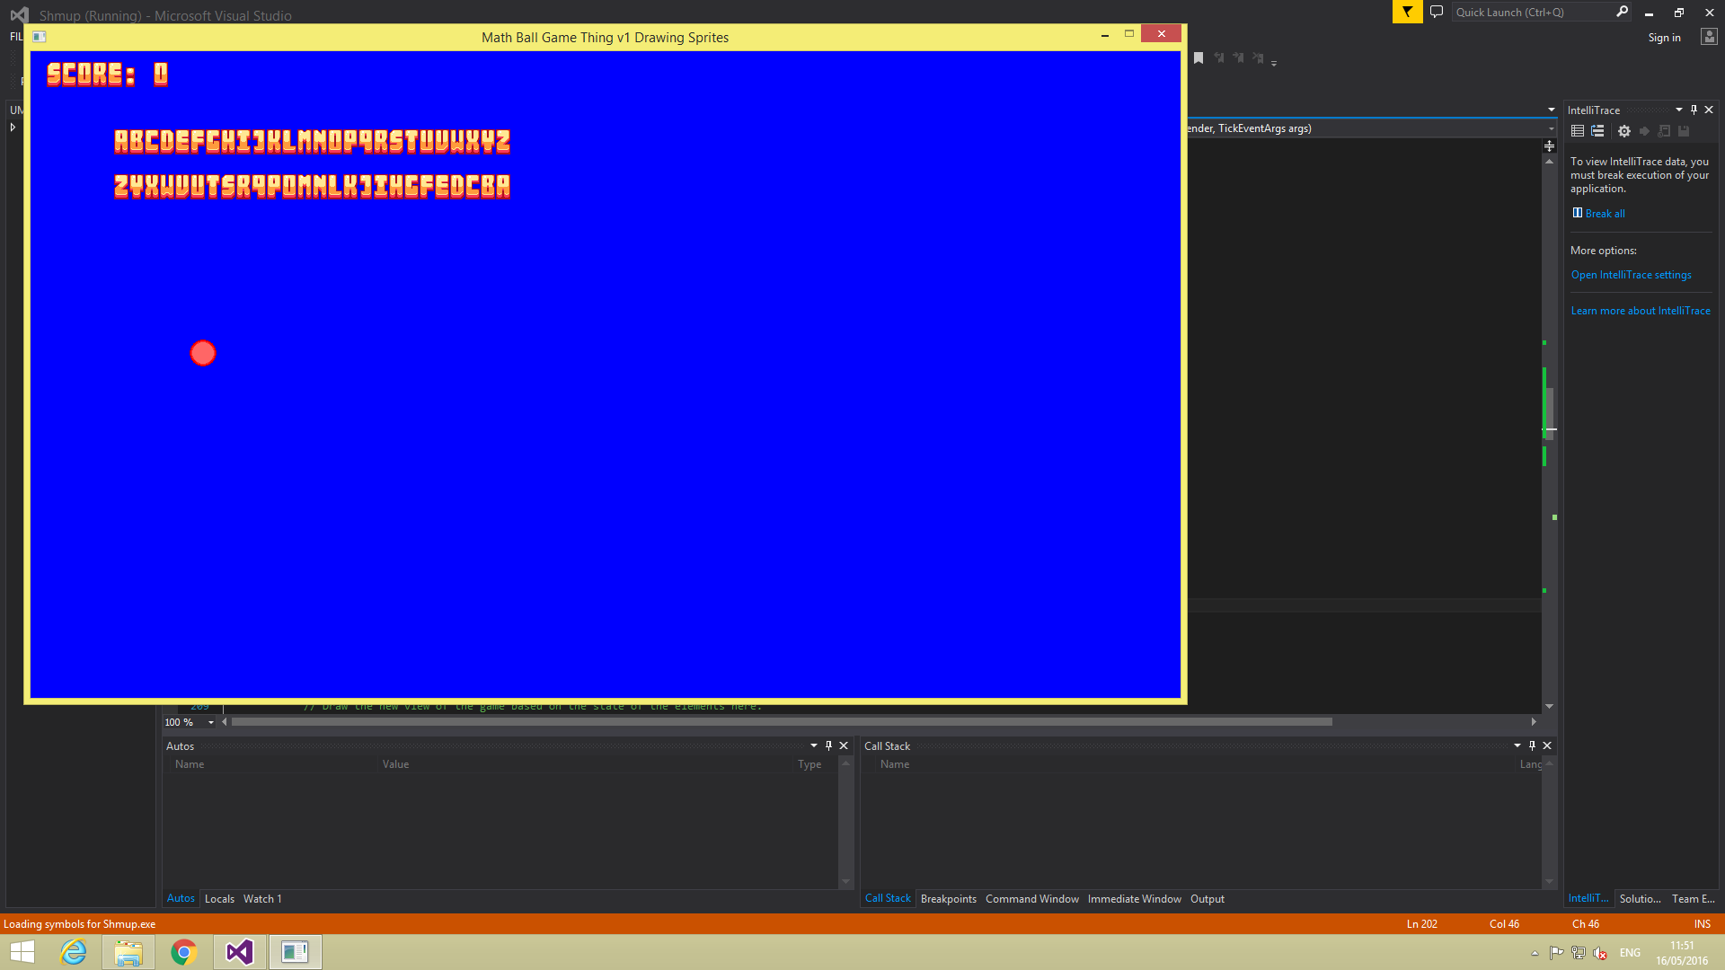

No bounce

This screenshot shows the ball not bouncing.

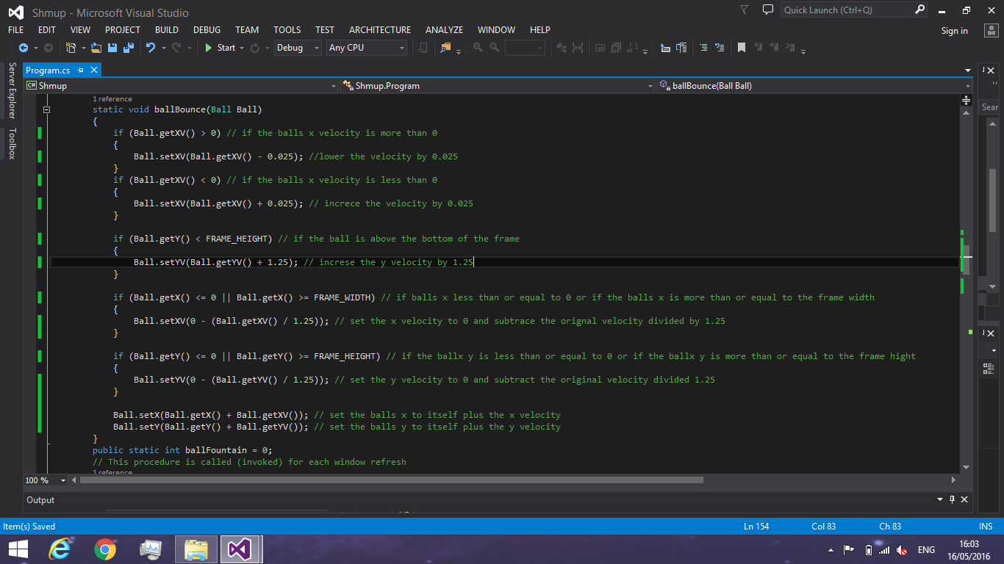

This screenshot show shows the code that represents de acceleration and gravity.

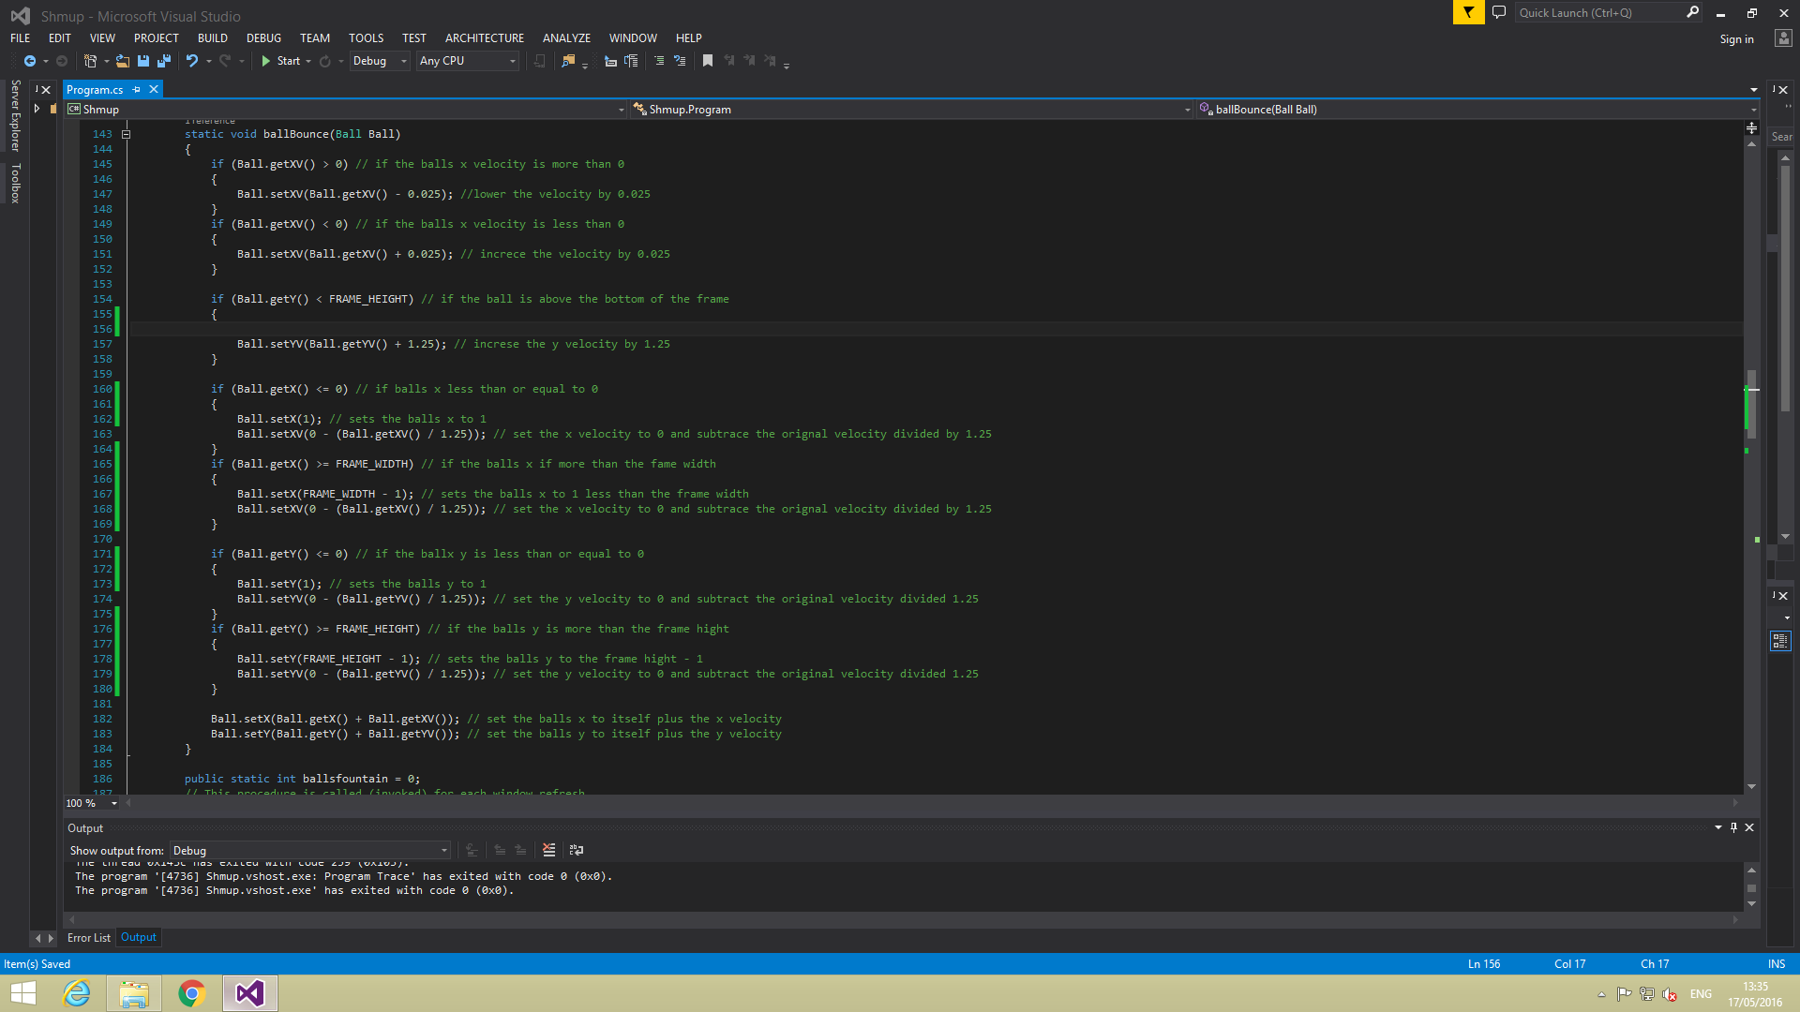

This screenshot shows the code that allows the ball to bounce of the walls and adds its velocity to its position so it moves across the screen.

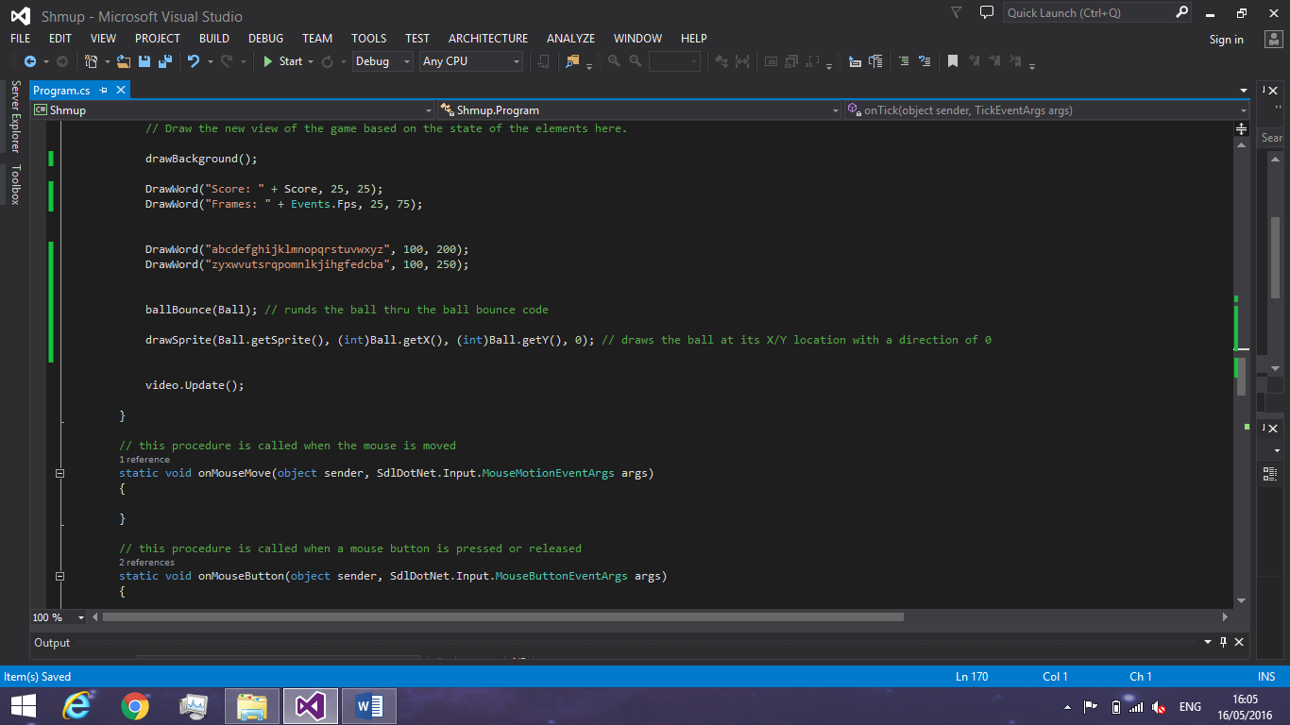

This code shows the ball going thru the ball bounce code and the ball being drawn at its x and y with designated sprite.

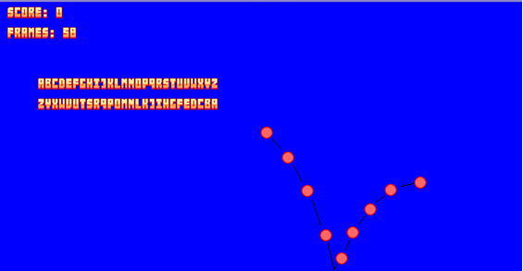

Ball Bounces

This screenshot shows the ball bouncing because of the code in the screenshots above.